Leveraging Public Private Partnerships for Service Delivery: A Case Study of Section 42 (not-for-profit) Companies in Punjab

Dr. Umair Javed, Bakhtiar Iqbal

Table of Contents

**Executive Summary** 2

**1. Background** 3

**2. Evaluation Criteria and Rationale** 6

**3. Case Studies** 6

**3.1. Punjab Population Innovation Fund (PPIF)** 6

**3.2. Punjab Skills Development Fund (PSDF)** 10

**4: Conclusion: Future Trajectories from the Section 42 Experience** 13

**Leveraging Public Private Partnerships for Service Delivery: A Case Study of Section 42 (not-for-profit) Companies in Punjab**

# **Executive Summary**

From 2010 onwards, the Government of Punjab set up a range of government-owned public sector companies (approximately 56 companies registered under Section 42 of the Companies Act 2017) to deliver specific public services such as waste management, public transport, parking regulation, infrastructure development, and skills training among others. The objective of this *corporatization* was to empower these companies with legal and financial autonomy and create public-sector companies that operated like the private sector, and were also expected to account for costs and revenues. The legal and financial autonomy would enable these companies to circumvent bureaucratic red tape, thus creating more efficiency and transparency.

Since their creation, Pakistan’s experience with these companies has been inconsistent at best. Some companies, such as the Punjab Saaf Pani Company are alleged to have misspent public funds to the tune of Rs. 4 billion. Still others have come under judicial and media scrutiny due to the salaries being paid to civil servants ‘beyond what they were entitled to’. In March of 2018, the then Chief Justice of the Supreme Court of Pakistan took *suo moto* notice against these companies alleging gross corruption. The resultant judicial and media trials have raised questions about the efficacy of the “companies model” of public good provision, as well as their accountability. Subsequently, there is question mark on the future of all companies.

This project attempted to address some of the confusion created by the media trial of the 56 Section 42 companies by presenting case studies on the performance of two successful public-sector companies and the reasons for their success. The performance of the selected companies was evaluated using a two-tier approach. The first level of parameters is the broader framework for governance and implementation that motivated the formation and proliferation of section 42 companies. The second level of parameters are company specific i.e. goals and targets, and to what extent the companies were able to meet their own targets, as well as overall contributions to the sectors in which they operate.

The analysis shows that public-sector gains significantly from the type of statutory and operational flexibility afforded by the Section 42 status. One of the most significant advantages of the Section 42 model is the ability to separate policy formulation, implementation, and monitoring, allowing the companies to achieve operational efficiency that would otherwise have been difficult in the traditional departmental setup. Moreover, the recruitment of private sector talent on market based renumerations allows the companies to build capacity without incurring large expenditures because of large public-sector employment and high current and administrative costs. The analysis also suggests that the presence of independent, proactive board that is staffed with requisite experience of oversight is absolutely necessary.

Going forward, sustaining the Section 42 model is integral for improving governance in Punjab, albeit with requisite reforms and strategic guidance put into place. The key reforms identified through this study include governmental commitment to company board autonomy, independence, and effectiveness; creating and following clear regulations for administrative management; and, lastly, exploring the possibility of creating an apex monitoring body that can ensure transparency of work and adherence to corporate best practices.

# **1. Background**

The 18th Amendment and the 7th National Finance Commission (NFC) in 2010 ensured greater access to funds and resources for provincial governments. Simultaneously, an increasingly urban population placed greater demands on the public sector for service delivery. However, public sector capacity did not increase accordingly- either to take advantage of the increased resources or to respond to increasingly complex service delivery requirements. As a result of these factors, over the past decade the Government of Punjab set up a number of public sector companies under Section 42 of the Companies Act 2017 for improving service delivery in the province. Between 2007 and 2018, approximately 55 public sector companies were set up to cover different aspects of service delivery where the pre-existing government machinery was either dysfunctional or absent with a focus on municipal services. These included the Lahore Waste Management Company, Lahore Parking Company, Lahore Transport Company, Punjab Skills Development Fund, Punjab Population Innovation Fund, Punjab Health Initiatives Management Company, and others.

***Figure 1: Growth of Section 42 Companies in Punjab***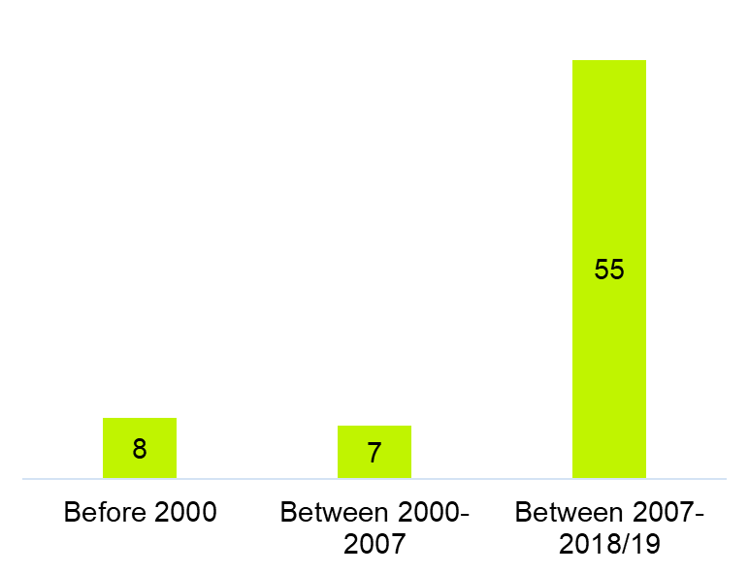

*Source: Planning and Development Department, Punjab*

By setting up the publicly-owned companies, the province initiated a ‘*corporatization’* of service delivery by augmenting the capacity of the public sector to deliver increasingly complex public services, and by empowering the companies with the financial and legal autonomy necessary to do so. This corporatization of service delivery and governance was premised on a clear set of rules and principles – such as transparency, accountability, and integrity – as well as clear risk management and control mechanisms. Moreover, while ownership of the companies rested with various departments of the government, they were meant to operate in all other respects like private sector companies. This entailed operating outside the typical bureaucratic red tape and such constraining factors as the Public Procurement Regulatory Authority, bypassing lengthy rules and procedures for project approval, and also being expected to account for costs and revenues. In theory, all a company would need was a project proposal, vetted and endorsed by an independent board of directors, and approved directly by the Chief Minister. The companies would also be able to draw upon the best talent available in the country directly, while benefiting from civil society partnership at the top levels of management.

A key objective behind creating the Section 42 companies was that by delivering public services in a different mode, the public sector would be able to create efficient management structures and incentivize performance by using successful private sector and non-governmental organization models for service delivery.

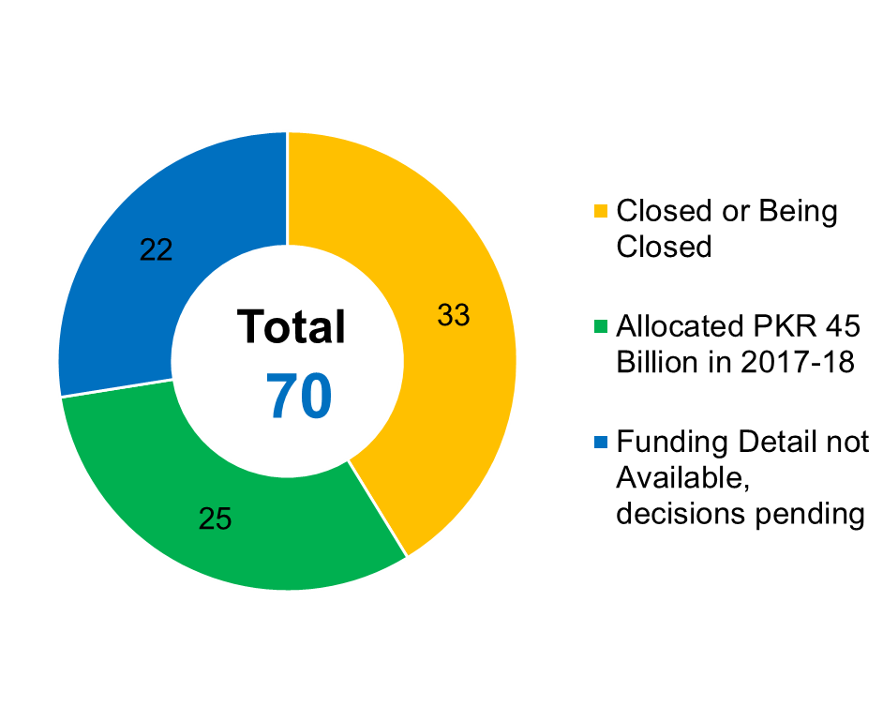

***Figure 2: Current Status of Section 42 Companies in Punjab***

*Source: Planning and Development Department, Punjab*

*Controversy and Judicial Scrutiny*

Since their inception, Punjab’s experience with the Section 42 companies has been inconsistent at best. While some companies such as the Punjab Skills Development Fund (PSDF) are lauded as examples of successful public-private partnership, collectively the Section 42 companies are alleged to have misspent public funds anywhere between Rs. 80 billion and Rs. 150 billion. The most prominent of these is the Punjab Saaf Pani company which is alleged to have used up Rs. 4 billion without even starting operations. Corruption and irregularities are asserted in the awarding of contracts, procurement, hiring, and disbursement of salaries.

Judicial and media scrutiny into the operations of the Section 42 companies began when the National Accountability Bureau (NAB) launched a thorough probe into their affairs for their alleged involvement in corruption. This was preceded by allegations of nonperformance and corruption against the Punjab Saaf Paani Company, and the subsequent arrest of its managers in November 2017. Taking notice of the developments in the Saaf Pani case, in March 2018, the then Chief Justice of Pakistan Saqib Nisar took suo moto notice of the inflated salaries being paid to the civil servants who were acting as Chief Executive Officers (CEOs) of the Section 42 companies. On top of the other corruption allegations, the primary argument used by the Chief Justice was the illegality of paying salaries to civil servants beyond their entitlement.

The judicial and media scrutiny has raised question marks over the future of the Section 42 companies, and whether or not the government will close them down. As it is, many companies have either been shut down or merged with other companies. While allegations of corruption in some cases may or may not be true, uncertainty about the future has harmed the operations of those companies that were living up to their mandate and delivering public services effectively. What has been missing from the public discourse so far is a lack of facts about the entire situation. While the media and the judiciary has focused on the negatives, what has been ignored are the cases where to companies were doing their jobs effectively. A key point worth raising is that shutting down all Section 42 companies would also entail suspending major aspects of service-delivery in the entire province, causing significant problems to the government. As the following figure shows, the majority of Section 42 companies are involved in municipal service delivery.

***Figure 3: Distribution of Companies by Administrative Department***

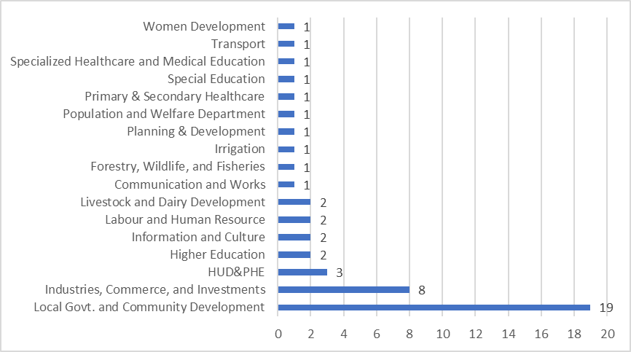

*Source: Punjab Government*

What is needed at this point is clarity about which companies are performing well, and why they are performing well, so that lessons may be learnt and applied to other companies. In this project, we present two case studies of successful companies that have lived up to their mandate in order to determine the fundamental prerequisites of success to enable the government to learn from these companies.

In response to a demand by Dr. Ishrat Hussain (Adviser to the Prime Minister for Institutional Reform and Austerity) the two companies selected as examples are the Punjab Skills Development Fund (PSDF) and the Punjab Population Innovation Fund (PPIF), which have received wide-scale appreciation across governments and continue to be supported by a range of stakeholders, despite the uncertainty around the Section 42 company model. This project thus seeks to add to the literature on public service delivery in developing countries, as well as respond to a specific policy demand.

## **2. Evaluation Criteria and Rationale**

The evaluation criteria for the two case studies selected operates at a two-tier level. Firstly, selected case studies are placed within the broader framework for governance and implementation that motivated the formation and proliferation of section 42 companies. Secondly, the companies’ performance is summarized on the sectoral grounds under which they were established, i.e. the contributions made by the two case-study companies in their respective sectors.

The general rationale for section 42 companies is premised upon an evaluation of the shortcomings of the existing system of department-driven administration and service delivery at the provincial level, and the greater complexity of policy related challenges. With increased urbanization, sophistication of economic activity, sustained demographic pressure on pre-existing municipal infrastructure, and clearer delineation of development priorities, a wide array of policy stakeholders agreed that the existing model of subnational governance, in particular, was not delivering.

In some service delivery-oriented departments, there was limited capacity for medium and long-term planning, which meant that either there was no accurate forecasting of the scale of public investment required to address developmental challenges, or when public investment was scaled up, it did not produce desirable outcomes due to underlying capacity constraints.

The persisting issue of policy innovation and capacity constraints has been repeatedly identified as part of the problem that Section 42 companies were designed to address. Borrowing from New Public Management principles, the goal was to increase efficiency and capacity through the induction and adoption of private-sector technocratic and managerial talent and techniques, focus on outcomes rather than procedures, and separate policymaking and implementation functions. At the same time, the creation of specially designed and focused vehicles for innovation and implementation would also provide a cost advantage due to reduced liabilities and flexible human resource management. Collectively these priorities were deemed to be only possible through the creation of new governance vehicles, as the entrenchment, inertia, and framework of the existing system did not lend itself easily to reform.

## **3. Case Studies**

For this assessment paper, two companies were selected for the purposes of diagnosing what contributed to their performance and whether they were able to leverage the overall advantages offered by the Section 42 company legal framework, along the rationale listed in the previous section. These two are the Punjab government supported Punjab Population Innovation Fund (PPIF), and the Punjab government and DFID supported Punjab Skills Development Fund (PSDF).

### **3.1. Punjab Population Innovation Fund (PPIF)**

PPIF was formally established on the 4th of October, 2016 under Section 42 of the Companies Act, with the explicit mission to ‘incubate and scale innovations that help achieve family planning goals.’ The larger mission of the company was geared towards focusing on poor and underserviced areas, which the conventional system of family planning and population welfare administration was unable to approach. This was to be done by strategically positioning PPIF to enhance private sector engagement and public-private partnerships in the population welfare and family planning space, pilot out innovative solutions, and generate robust evidence on what ultimately worked to achieve the stated goals. The goal of all interventions was to increase access to services, especially in underserved urban and rural areas, through innovative approaches in communication and service delivery, while creating greater value for money in comparison to the traditional public sector delivery model.

Its programmatic rationale was premised on the fact that Pakistan’s fertility trends are some of the worst in the region, with the population growth rate at 2.4% per annum, and the number of births per woman at 3.6 (nearly 4 in rural areas) while falling at a very slow rate over the preceding decade. With the given rate of decline, it is expected that it would take another 25 years for the fertility rate to reduce by one child. Pakistan currently ranks within the bottom five countries in terms of the contraceptive prevalence rate (CPR), an important reason for its poor demographic profile.

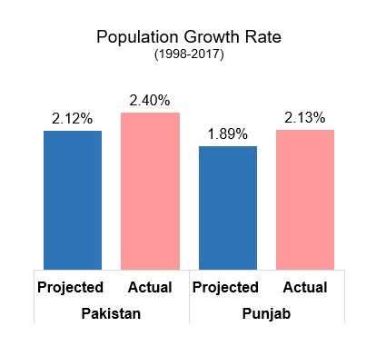

***Figure 4: Population Growth Rate***

*Sources: World Bank and Punjab Development Statistics 2016*

PPIF was consequently tasked with filling in gaps in the fertility health and family planning space, by providing programmatic support to the existing Population Welfare Department (PWD). PWD suffers from significant outreach and other supply-side issues, and its capacity to undertake extensive outreach and serve poor and marginalized segments in particular is quite limited. PPIF was expected to fill in this particular space, by leveraging its quasi-governmental status, and supporting the PWD in the identified gaps of outreach and affiliated supply-side constraints. Importantly, however, the governing architecture of PPIF was made independent, through the constitution of an autonomous board.

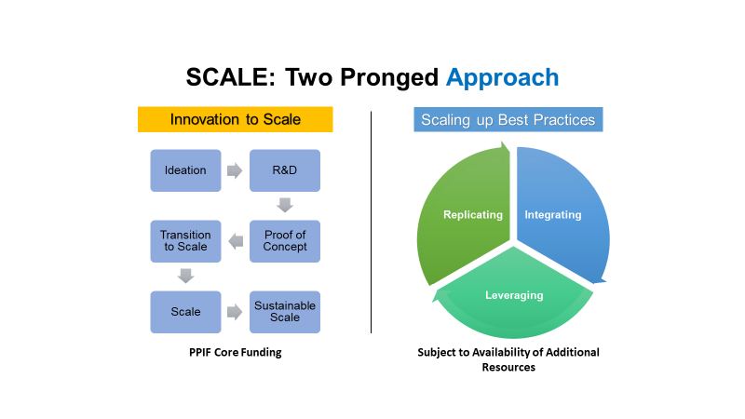

***Figure 5: PPIF Approach***

*Source: PPIF*

***Performance Review***

In its three and a half years of operation, PPIF has initiated 6 pilot projects across three program cycles to assess what works in enhancing CPR and to improve family planning related outreach in the province. In each of these 5 projects, it has partnered with a non-governmental organization, with PPIF acting primarily as the funding and evaluation arm. Total planned disbursements are just under Rs. 200 million, with 8 districts, including 4 in South Punjab, as the geographic area for the interventions. The funding for these projects has to date come from the Punjab government’s Annual Development Plan (ADP), through three rounds of financing.

The performance in Cycles 1 and 2 has been impressive with targets being achieved or exceeded by all implementing partners. The take-up rate of family planning services in the targeted populations has seen a 14% increase, with strong follow-up evaluations. This in itself suggests a major departure from the outcomes usually achieved by PWD interventions. A project in 15 LHW uncovered Union Councils of District Muzaffargarh, for example, implemented by Health and Nutrition Development Society (HANDS), was able to generate 11,226 Additional New Users, and reached over 40,000 Married Women of Reproductive Age. As per the desired goals of PPIF, this and other projects funded in the two program cycles were also able to identify important opportunities for scaling up implementation in LHW uncovered areas of 36 districts of Punjab. In Cycle 3, PPIF is also testing an innovative model for increase in FP uptake among BISP beneficiaries in District Rahm Yar Khan.

Assessment of program documents and interviews with PPIF staff reveal that partner performance outcomes are closely tied to the monitoring and evaluation systems set up by the organization. For the first time in the public-sector governed family planning space, grant disbursements were tied to milestone achievement, which underwent independent verification.

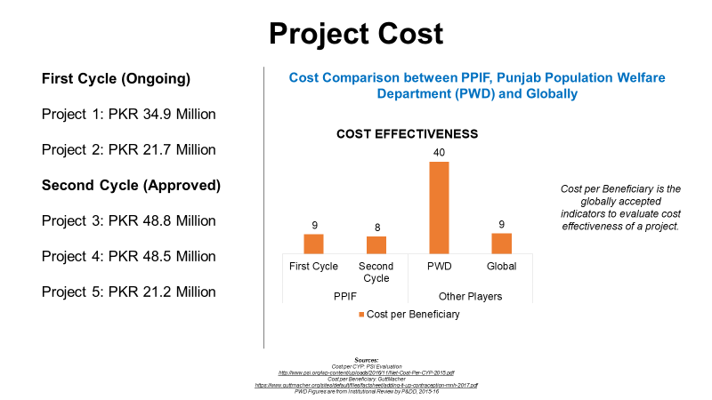

***Figure 6: Value for Money proposition of PPIF***

*Source: PPIF*

The cost advantage of PPIF over the existing system has been quite significant. The average cost per beneficiary over the first two PPIF program cycles has been on average 5 times less than that which is incurred by PWD through its programming. This figure also compares equally with what are considered acceptable and standard costs per beneficiaries in other parts of the world in the domain of family planning interventions. Total administrative and programmatic expenditure till June 2019 (end of last fiscal year) was just over Rs. 250 million, while audit external audits for its first two years of operation returned unqualified reports. Of considerable importance in its three complete years of programming is also the fact that programmatic expenditures totaled just over 50% of all expenditures incurred, which is significantly better than the public-sector average in social sector programming.

***What Worked?***

A review of PPIF’s program documents and interviews with key personnel highlight a number of factors that have contributed to its performance over the preceding three years. It is also possible to ascertain that much of this success can be traced back to the organizational dynamics afforded by its legal status.

**Leveraging Private Sector Talent**: Firstly, PPIF was able to draw in extensive private sector human resource capacity at competitive, market-based remuneration for nearly all of its programmatic and administrative position. Apart from the CEO, who is a member of the PAS cadre of the CSS, all of the 24 remaining filled positions are from the private sector. Importantly, this includes technical resources in financial oversight, grant-administration, monitoring, operations, and procurement. Several of the personnel working in PPIF have past experience of working in the family planning space with a number of non-governmental and other private-sector actors.

**Proactive and Independent Board**: Secondly, PPIF benefited immensely from the presence of an independent and proactive board that had private members experienced in programmatic design, implementation, and evaluation (Dr. Ijaz Nabi and Dr. Naved Hamid), as well as technical experts who understood the family planning and population welfare space in Pakistan (Dr. Yasmin Qazi and Dr. Muhammad Tayab). The proactive character of the board, in particular, has been repeatedly identified as a key facet in ensuring the advantageous results produced by PPIF over a relatively short period of time.

**Organizational Flexibility:** Third, the programmatic flexibility offered by the Section 42 structure allowed PPIF to form partnerships with non-profit and other private-sector actors in a timely manner, and maintaining control over disbursements and financial oversight allowed it to bypass lengthy procedures that usually afflict public-sector organizations. By operating as a fund model (rather than as a direct implementor) and setting technical guidelines and channeling demand for the private sector to intervene in, it has also helped create a nascent market in private-sector led provision of family planning services. The separation of key aspects of the service delivery space also allow it to act as an effective evaluator, since the funding, design, and implementation aspects are being carried out by different actors.

### **3.2. Punjab Skills Development Fund (PSDF)**

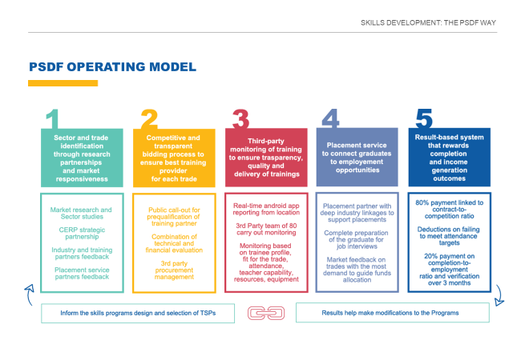The Punjab Skills Development Fund (PSDF) was established in 2010 as a Section 42 company, with the explicit mandate to produce new, market-oriented innovations in the skills training sector. With 36% of the country’s population between the ages of 16 and 29, the importance of skills-training in an environment where two million people enter the workforce each year cannot be understated. With historically low youth education attainment levels – 60% for primary education, 28% for secondary education, and 12% for tertiary education – skills training can play a key role in equipping the youth with the necessary skillset required to be gainfully employed, while providing industry with a pool of skilled workers at the same time.

***Figure 7: PSDF Approach***

However, the traditional skills training infrastructure, largely dominated by government-run providers was repeatedly found to be inadequate, delinked from market demand, time-consuming, and extremely inefficient in terms of its commercial viability. The inefficiency built-in to the traditional skills training infrastructure also posits a poor value proposition for the government with the cost of training going up rapidly due to fixed overheads and costs delinked from utilization levels. PSDF’s model of creating a market of efficient, private-sector run training providers aims to address these shortcomings as well as expand outreach, while, at the same time, reducing the fiscal burden on the government.

Rectifying the shortcomings of the public-sector run training infrastructure thus went into the rationale of setting up PSDF. Its operating model was able to reflect this underlying premise, as it developed a sequenced operating model that first draws on market research to identify training gaps, solicit training providers through a competitive and transparent bidding process, ensure reliability of training through third party technical and financial monitoring, provides placement support to trainees, and institutionalizes a results-based system that rewards completion and sets contract payments to milestone and employment achievement.

As with the PPIF example discussed above, the move towards innovative, decentralized private-sector providers underscores PSDF’s commitment to creating a new market in vocational and skills-related training, an area that has historically been dominated by extensive and costly public sector infrastructure. What makes PSDF different from most other Section 42 companies, however, is the financial and operational support given to it by the UK Government’s Department for International Development (DFID), who have played a key role in financing its programmatic work. This support has totaled upwards of £46 million, which was historically matched by the Punjab government, and has now been exceeded by the latter.

*Performance Review*

PSDF has achieved significant success in its core area of training provision. Since its inception just under a decade ago, over 450 PSDF funded training providers – all of whom were selected through a competitive process that also evaluates their technical, legal, and financial status - have trained approximately 350,000 trainees, across 250 trades and in 2000 distinct locations.

40% of the trainees have been women, and over 60% are currently engaged in income generating activities. These achievements have also come at a significant cost advantage, compared to the traditional public sector. PSDF sponsored trainings are estimated to cost at least 30% less per beneficiary compared to the traditional public-sector run model, largely because PSDF does not incur expensive infrastructure and operational costs, which, in its model, are internalized by the private training provider. In total, PSDF’s operational expenditure is only 6.4% of its total outlay, which is considerably lower than the cost-breakup in the traditional public-sector driven model of trainings.

In 2019, PSDF undertook a mid-program Graduate Tracer Study of the DFID-Skills Development Program (SDP). The results of this tracer study also speak to the success of the PSDF model. As part of the SDP, PSDF trained 152,751 graduates, of which 59441 were enrolled in formal training institutes, 53345 in industry driven programs, and 39965 in community-based programs. Total SDP spending until 31st January 2019 was PKR 6.3 billion which resulted in total annualized incomes of PKR 13.8 billion, creating a total skills incomes premium of PKR 6.2 billion.

The SDP had similar positive effects on labor force participation and overall employment rates.

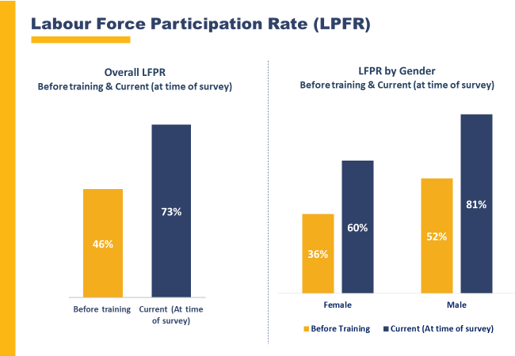

***Figure 8: Effect on Labor Force Participation Rate (LFPR)***

*Source: PSDF*

***Figure 9: Effect on Employment***

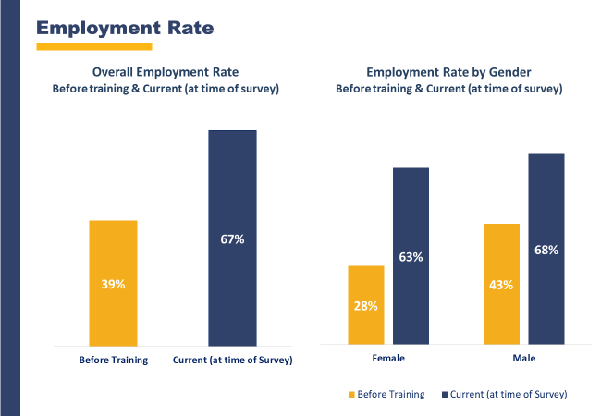

*Source: PSDF*

***What Worked***

**Leveraging Private Sector Talent:** As with PPIF, there are some integral commonalities in terms of the factors that contributed to PSDF’s success. Most prominently, the use of private sector talent throughout the organization (“from top to bottom”) has ensured the placement of the right people with the right skills in key roles. The company has also instituted a corporatized human resource management culture within the organization, with defined roles and parameters, career progression and planning, and a rewarding work culture. This has allowed it to cultivate a reputation as one of the top thirteen companies to work for in the country, thus attracting good talent from the labor market.

**Independent and Proactive Board:** The role of the board here too has been very important, with clear policy guidance and direction, as well as strong oversight of the company’s operations. The presence of public-sector members (Govt. of Punjab Secretaries from relevant departments) on the board has produced mixed consequences, however, any detrimental role has been diluted due to the authority exercised by private-sector members.

**Organizational Flexibility:** Like with PPIF, the flexibility afforded to PSDF by its status as a Section 42 company has been most useful in its procurement and contracting domains, as well as in its take-up of private sector talent, which it can then provide market-based compensation. It has also made it less susceptible to governmental pressure on the nature of training programs, and has allowed it to cultivate its own needs-based and market-driven metrics.

**Donor Involvement:** Unlike PPIF, however, PSDF still has extensive operational and financial oversight from DFID, due to the funding arrangement between the two. Even though DFID’s share in overall financial support has decreased, with the Punjab government increasing its disbursement to PSDF, it still retains oversight on financial controls, operational compliance, policy formation, audit requirements, and fiduciary responsibilities. DFID also exercises considerable leverage over the government due to its relationship, thus helping PSDF maintain its operational and policy-related autonomy in this domain.

## **4: Conclusion: Future Trajectories from the Section 42 Experience**

The continued uncertainty over the future of Section 42 companies also provides an opportunity to draw out key lessons and ensure that concerns over accountability, transparency, and sustainability are addressed, without compromising on the flexibility and efficiency gains that the companies provide. The PSDF and PPIF case-studies, interviews with company personnel, and review of the literature provide us with insight into possible future course of action with regards to the governing architecture of service delivery in the province.

**Sustaining Public-Private Partnerships:** The operational efficacy and commercial viability of public-private partnerships as demonstrated through the performance of several Section 42 companies, and the statutory flexibility offered by its model, are crucial for improving service delivery and governance. The traditional departmental model that merges policy formulation with implementation and monitoring has become both obsolete and ossified, and with its skewed incentives due to merged functions, cost inefficiency because of large public-sector employment and high current and administrative costs, render it problematic; reforming it to produce the kind of flexibility and innovation offered by Section 42 companies is a non-starter, which is why the latter must be maintained as a key plank in public sector-led governance.

**Empowering Company Boards for Accountability:** At the same time, it would be amiss to suggest that the current Section 42 model cannot benefit from reform. Among the 70 companies formed in Punjab over a ten year period, several were unable to produce any notable gains nor guarantee the kind of cost efficiency and innovation for which they were brought into existence. The analysis of PPIF and PSDF, two well-performing companies, suggests that the presence of independent, proactive board that is staffed with requisite experience of oversight is absolutely necessary. In that sense, it is reasonable to suggest that in the absence of an empowered board, these companies would be unable to deliver commercial viability, and would be unable to leverage the capacity gains through private sector talent and the organizational flexibility afforded by their statutory status.

**Leadership Criterion for Companies:** The PPIF and PSDF cases present interesting contrasts on the occupational profile of the company leadership, with the former being led by a career civil servant and the latter by a private-sector manager. At this point, it is difficult to suggest that there can be a hard-and-fast rule developed for the leadership of such organizations, given the different talent and experiences that can be harnessed. What is, however, clear is that the technical positions and other key aspects of the organization’s human resource profile need to be brought in from the private sector to ensure capacity and technocratic viability. This along with accountability to a high-capacity and independent board will ensure that some of the mistakes made earlier in certain companies with regards to staffing of positions are not repeated.

**Establishing Synergetic Administrative Support:** Despite their legal status, the companies are still reliant on parent departments for their administrative support, including budgetary aspects of their functioning. In many instances administrative backends were handed over the P&D Department, but in some instances these were shifted to the department in whose sector domain the company was working within. The experience on this front has been decidedly mixed, with companies being viewed by the parent department with hostility and a confrontational mindset. The absence of clear-cut messaging that could delineate the value-addition that the companies bring, along with a reform to the existing government rules dictating administrative and financial procedures would go some way to improving this particular issue.

**Setting up Monitoring Systems:** Another possible suggestion to address issues of transparency and accountability would be to develop a province-wide monitoring and regulatory body that is responsible for ensuring compliance to corporate practices within Section 42 companies, and ensures that company boards are doing their jobs independently and effectively. Such a system could also potentially ensure regular third-party audits of technical and financial performance, thus establishing a baseline level of performance that all companies would have to adhere to. The Special Monitoring Unit (SMU) of the Chief Minister’s Office could be repurposed for this particular task.